Smart Lender - Applicant Credibility Prediction for Loan Approval

Project Description:
One of the most important factors which affects our country’s economy and the financial condition is the credit system governed by the banks. The process of bank credit risk evaluation is recognising at banks across the globe. “As we know credit risk evaluation is very crucial, there are variety of techniques are used for risk level calculation. In addition, credit risk is one of the main functions of the banking community.
The prediction of credit defaulters is one of the difficult task for any bank. But by forecasting the loan defaulters, the banks definitely may reduce its loss by reducing its non-profit assets, so that recovery of approved loans can take place without any loss and it can play as the contributing parameter of the bank statement. This makes the study of this loan approval prediction important. Machine Learning techniques are very crucial and useful in prediction of these type of data.
We will be using classification algorithms such as Decision tree, Random forest, KNN, and xgboost. We will train and test the data with these algorithms. From this best model is selected and saved in pkl format. We will be doing flask integration and IBM deployment.

Technical Architecture:
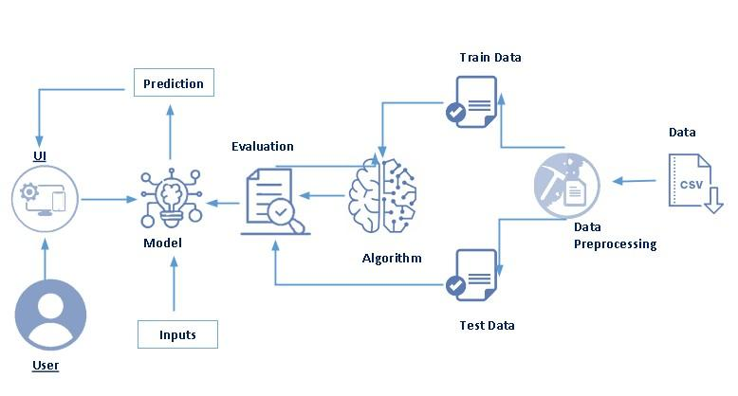

Pre requisites:
To complete this project, you must required following software’s, concepts and packages
- Anaconda navigator and pycharm:
  - Refer the link below to download anaconda navigator
  - Link : https://youtu.be/1ra4zH2G4o0
- Python packages:
  - Open anaconda prompt as administrator
  - Type “pip install numpy” and click enter.
  - Type “pip install pandas” and click enter.
  - Type “pip install scikit-learn” and click enter.
  - Type ”pip install matplotlib” and click enter.
  - Type ”pip install scipy” and click enter.
  - Type ”pip install pickle-mixin” and click enter.
  - Type ”pip install seaborn” and click enter.
  - Type “pip install Flask” and click enter.

Prior Knowledge:
You must have prior knowledge of following topics to complete this project.
- ML Concepts
  - Supervised learning: https://www.javatpoint.com/supervised-machine-learning
  - Unsupervised learning: https://www.javatpoint.com/unsupervised-machine-learning
  - Regression and classification
  - Decision tree: https://www.javatpoint.com/machine-learning-decision-tree-classification-algorithm
  - Random forest: https://www.javatpoint.com/machine-learning-random-forest-algorithm
  - KNN: https://www.javatpoint.com/k-nearest-neighbor-algorithm-for-machine-learning
  - Xgboost: https://www.analyticsvidhya.com/blog/2018/09/an-end-to-end-guide-to-understand-the-math-behind-xgboost/
  - Evaluation metrics: https://www.analyticsvidhya.com/blog/2019/08/11-important-model-evaluation-error-metrics/
- Flask Basics : https://www.youtube.com/watch?v=lj4I_CvBnt0

Project Objectives:
By the end of this project you will:
- Know fundamental concepts and techniques used for machine learning.
- Gain a broad understanding about data.
- Have knowledge on pre-processing the data/transformation techniques on outlier and some visualization concepts.

Project Flow:
- User interacts with the UI to enter the input.
- Entered input is analyzed by the model which is integrated.
- Once model analyses the input the prediction is showcased on the UI

To accomplish this, we have to complete all the activities listed below,
- Data collection
  - Collect the dataset or create the dataset
- Visualizing and analyzing data
  - Univariate analysis
  - Bivariate analysis
  - Multivariate analysis
  - Descriptive analysis
- Data pre-processing
  - Checking for null values
  - Handling outlier
  - Handling categorical data
  - Splitting data into train and test
- Model building
  - Import the model building libraries
  - Initializing the model
  - Training and testing the model
  - Evaluating performance of model
  - Save the model
- Application Building
  - Create an HTML file
  - Build python code

Project Structure:
Create the Project folder which contains files as shown below
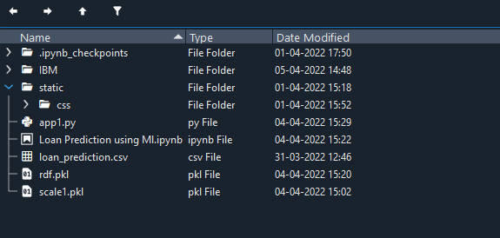
- We are building a flask application which needs HTML pages stored in the templates folder and a python script app.py for scripting.
- rdf.pkl is our saved model. Further we will use this model for flask integration.
- Training folder contains model training files and training_ibm folder contains IBM deployment files.

Milestone 1: Data Collection
ML depends heavily on data, It is most crucial aspect that makes algorithm training possible. So this section allows you to download the required dataset.
Activity 1: Download the dataset
There are many popular open sources for collecting the data. Eg: kaggle.com, UCI repository, etc.
In this project we have used drug200.csv data. This data is downloaded from kaggle.com. Please refer to the link given below to download the dataset.
Link: https://docs.google.com/spreadsheets/d/1T4tlqMwRXEpYdWlneX2sY5UqrcsVIMMirgkTOKLdkI/edit#gid=1373903219

Milestone 2: Visualizing and analysing the data
As the dataset is downloaded. Let us read and understand the data properly with the help of some visualization techniques and some analysing techniques.
Note: There is n number of techniques for understanding the data. But here we have used some of it. In an additional way, you can use multiple techniques.
Activity 1: Importing the libraries
Import the necessary libraries as shown in the image. (optional) Here we have used visualization style as fivethirtyeight.
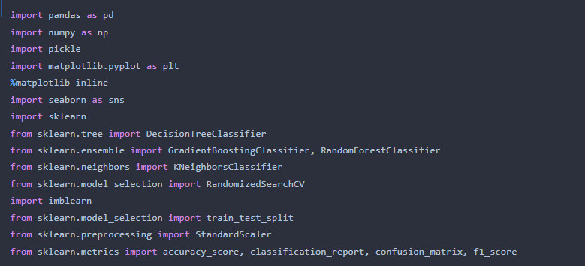
Activity 2: Read the Dataset
Our dataset format might be in .csv, excel files, .txt, .json, etc. We can read the dataset with the help of pandas.
In pandas we have a function called read_csv() to read the dataset. As a parameter we have to give the directory of csv file.
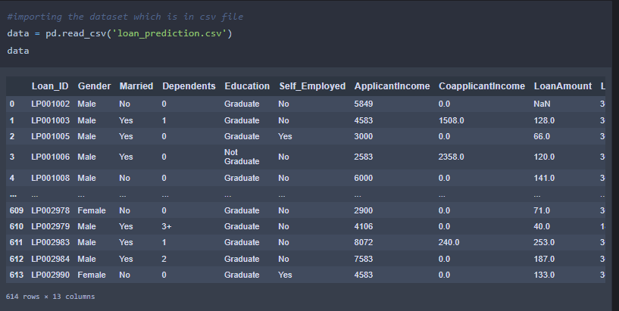
Activity 3: Univariate analysis
In simple words, univariate analysis is understanding the data with single feature. Here we have displayed two different graphs such as distplot and countplot.
- Seaborn package provides a wonderful function distplot. With the help of distplot, we can find the distribution of the feature. To make multiple graphs in a single plot, we use subplot.

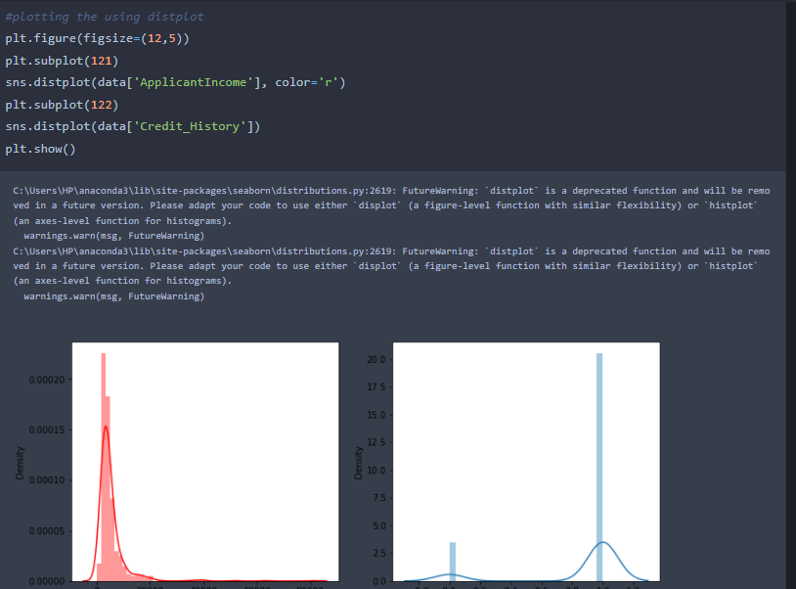

- In our dataset we have some categorical features. With the count plot function, we are going to count the unique category in those features. We have created a dummy data frame with categorical features. With for loop and subplot we have plotted this below graph.
- From the plot we came to know, Applicants income is skewed towards left side, where as credit history is categorical with 1.0 and 0.0

Countplot:-
A count plot can be thought of as a histogram across a categorical, instead of quantitative, variable. The basic API and options are identical to those for barplot() , so you can compare counts across nested variables.

From the graph we can infer that , gender and education is a categorical variables with 2 categories , from gender column we can infer that 0-category is having more weightage than category-1,while education with 0,it means no education is a underclass when compared with category -1, which means educated .

Activity 4: Bivariate analysis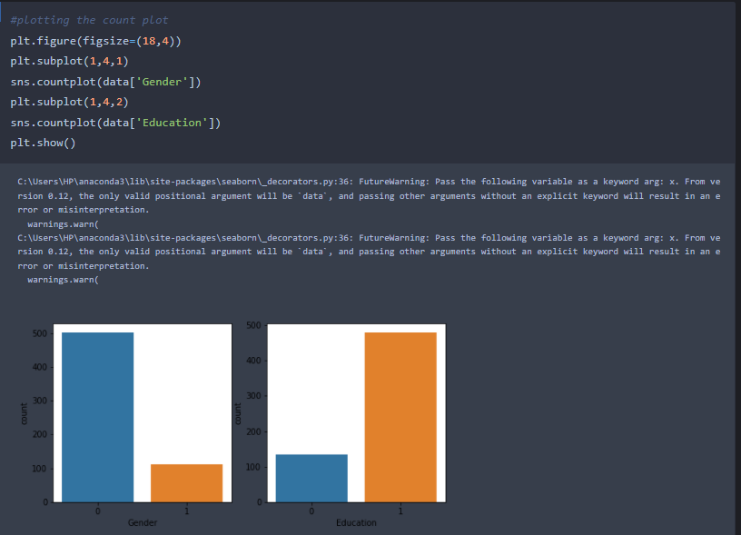
Countplot:-
A count plot can be thought of as a histogram across a categorical, instead of quantitative, variable. The basic API and options are identical to those for barplot() , so you can compare counts across nested variables.

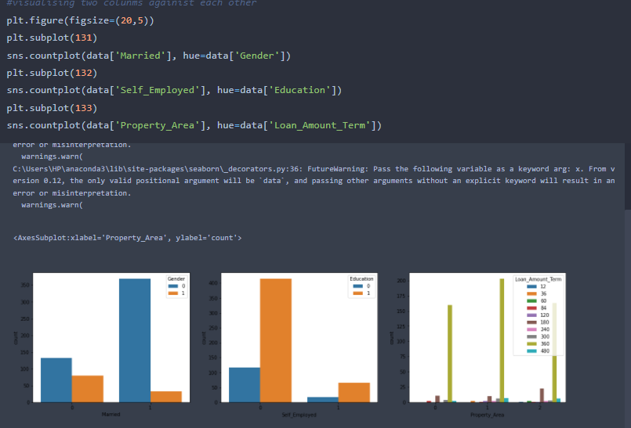
From the above graph we can infer the analysis such as
- Segmenting the gender column and married column based on bar graphs
- Segmenting the Education and Self-employed based on bar graphs ,for drawing insights such as educated people are employed.
- Loan amount term based on the property area of a person holding

Activity 5: Multivariate analysis
In simple words, multivariate analysis is to find the relation between multiple features. Here we have used swarm plot from seaborn package.
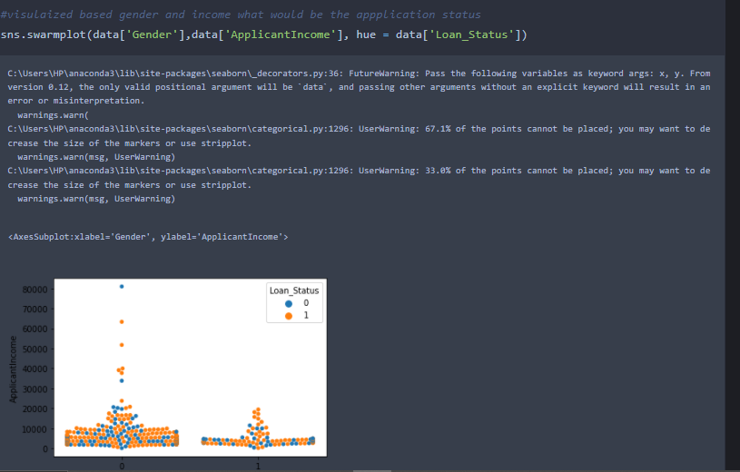
From the above graph we are plotting the relationship between the Gender, applicants income and loan status of the person

Activity 6: Descriptive analysis
Descriptive analysis is to study the basic features of data with the statistical process. Here pandas has a worthy function called describe. With this describe function we can understand the unique, top and frequent values of categorical features. And we can find mean, std, min, max and percentile values of continuous features.
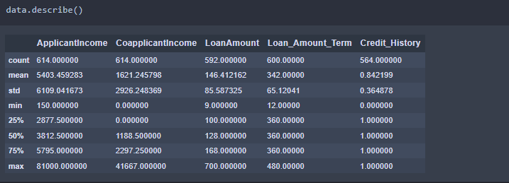

Milestone 3: Data Pre-processing
As we have understood how the data is lets pre-process the collected data.
The download data set is not suitable for training the machine learning model as it might have so much of randomness so we need to clean the dataset properly in order to fetch good results. This activity includes the following steps.
- Handling missing values
- Handling categorical data
- Handling outliers
- Scaling Techniques
- Splitting dataset into training and test set

Note: These are the general steps of pre-processing the data before using it for machine learning. Depending on the condition of your dataset, you may or may not have to go through all these steps.

Activity 1: Checking for null values
- Let’s find the shape of our dataset first, To find the shape of our data, df.shape method is used. To find the data type, df.info() function is used.
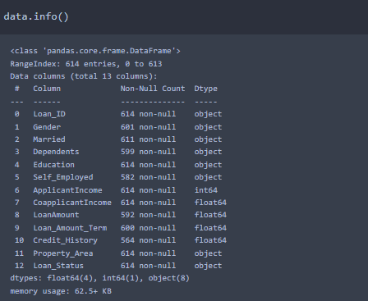

- For checking the null values, df.isnull() function is used. To sum those null values we use .sum() function to it. From the below image we found that there are no null values present in our dataset. So we can skip handling of missing values step.

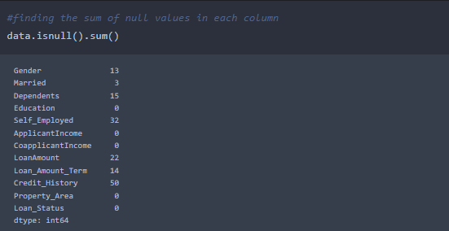
From the above code of analysis, we can infer that columns such as gender ,married,dependents,self employed ,loan amount, loan amount tern and credit history are having the missing values, we need to treat them in a required way.
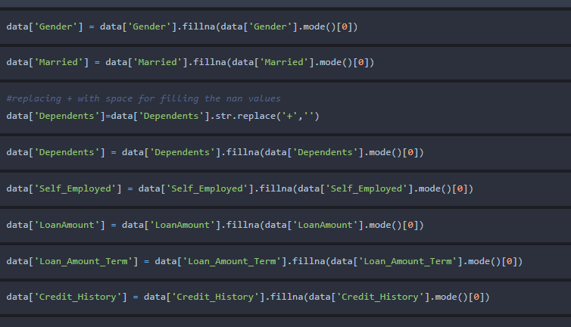

We will fill the missing values in numeric data type using mean value of that particular column and categorical data type using the most repeated value.

Activity 2: Handling Categorical Values
As we can see our dataset has categorical data we must convert the categorical data to integer encoding or binary encoding.
To convert the categorical features into numerical features we use encoding techniques. There are several techniques but in our project we are using manual encoding with the help of list comprehension.
- In our project, Gender ,married,dependents,self-employeed,co-applicants income,loan amount ,loan amount term, credit history With list comprehension encoding is done.

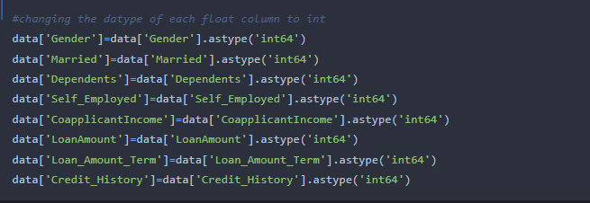

Activity 3: Balancing the dataset:
Data Balancing is one of the most important step, which need to be performed for classification models, because when we train our model on imbalanced dataset ,we will get biased results, which means our model is able to predict only one class element
For Balancing the data we are using SMOTE Method.
SMOTE: Synthetic minority over sampling technique, which will create new synthetic data points for under class as per the requirements given by us using KNN method.
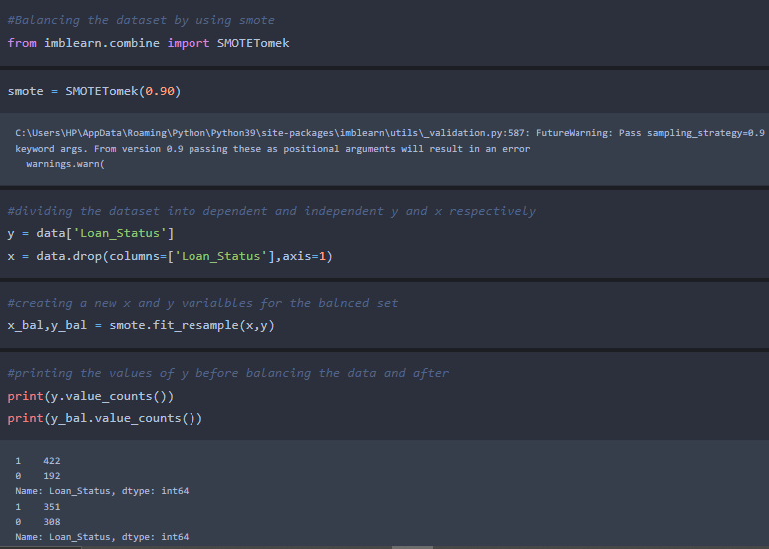
From the above picture, we can infer that ,previously our dataset is having 492 class 1, and 192 class items, after applying smote technique on the dataset the size has been changed for minority class.
Activity 4: Scaling the Data
Scaling is one the important process, we have to perform on the dataset, because of data measures in different ranges can leads to mislead in prediction
Models such as KNN, Logistic regression need scaled data, as they follow distance based method and Gradient Descent concept.
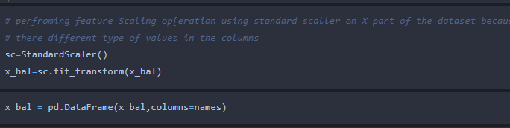
We will perform scaling only on the input values
Once the dataset is scaled, it will be converted into array and we need to convert it back to dataframe.
Activity : Splitting data into train and test
Now let’s split the Dataset into train and test sets
Changes: first split the dataset into x and y and then split the data set
Here x and y variables are created. On x variable, df is passed with dropping the target variable. And on y target variable is passed. For splitting training and testing data we are using train_test_split() function from sklearn. As parameters, we are passing x, y, test_size, random_state.
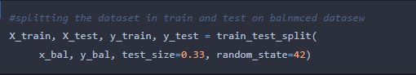

Milestone 4: Model Building
Now our data is cleaned and it’s time to build the model. We can train our data on different algorithms. for this project we are applying four classification algorithms. The best model is saved based on its performance.
Activity 1: Decision tree model
A function named decisionTree is created and train and test data are passed as the parameters. Inside the function, DecisionTreeClassifier algorithm is initialized and training data is passed to the model with .fit() function. Test data is predicted with .predict() function and saved in new variable. For evaluating the model, confusion matrix and classification report is done.
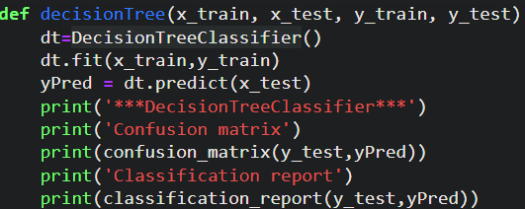
Activity 2: Random forest model
A function named randomForest is created and train and test data are passed as the parameters. Inside the function, RandomForestClassifier algorithm is initialized and training data is passed to the model with .fit() function. Test data is predicted with .predict() function and saved in new variable. For evaluating the model, confusion matrix and classification report is done.
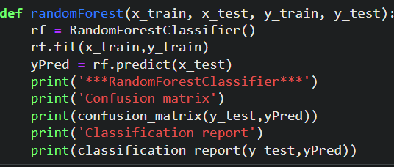
Activity 3: KNN model
A function named KNN is created and train and test data are passed as the parameters. Inside the function, KNeighborsClassifier algorithm is initialized and training data is passed to the model with .fit() function. Test data is predicted with .predict() function and saved in new variable. For evaluating the model, confusion matrix and classification report is done.
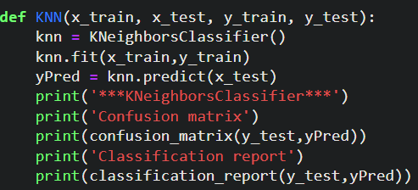
Activity 4: Xgboost model
A function named xgboost is created and train and test data are passed as the parameters. Inside the function, GradientBoostingClassifier algorithm is initialized and training data is passed to the model with .fit() function. Test data is predicted with .predict() function and saved in new variable. For evaluating the model, confusion matrix and classification report is done.
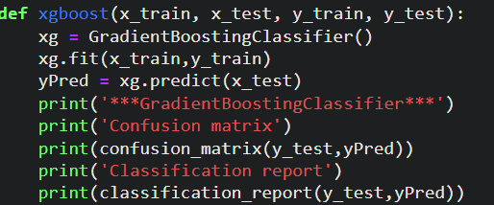
Now let’s see the performance of all the models and save the best model

Activity 5: Compare the model
For comparing the above four models compareModel function is defined.
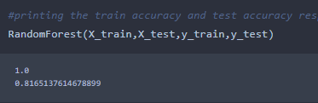
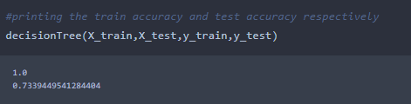
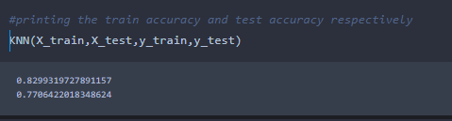
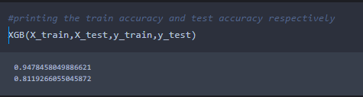
After calling the function, the results of models are displayed as output. From the four model Xgboost is performing well. From the below image, We can see the accuracy of the model. Xgboost is giving the accuracy of 94.7% with training data , 81.1% accuracy for the testing data.so we considering xgboost and deploying this model.

Activity 6: Evaluating performance of the model and saving the model
From sklearn, cross_val_score is used to evaluate the score of the model. On the parameters, we have given rf (model name), x, y, cv (as 5 folds). Our model is performing well. So, we are saving the model by pickle.dump().
Note: To understand cross validation, refer this link. https://towardsdatascience.com/cross-validation-explained-evaluating-estimator-performance-e51e5430ff85.
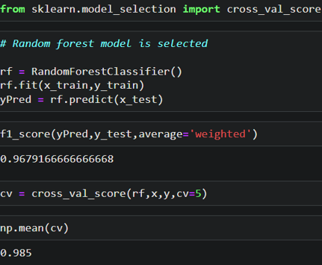
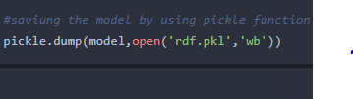

Milestone 5: Application Building
In this section, we will be building a web application that is integrated to the model we built. A UI is provided for the uses where he has to enter the values for predictions. The enter values are given to the saved model and prediction is showcased on the UI.
This section has the following tasks
- Building HTML Pages
- Building serverside script
Activity1: Building Html Pages:
For this project create three HTML files namely
- home.html
- predict.html
- submit.html
and save them in templates folder.

Let’s see how our home.html page looks like:
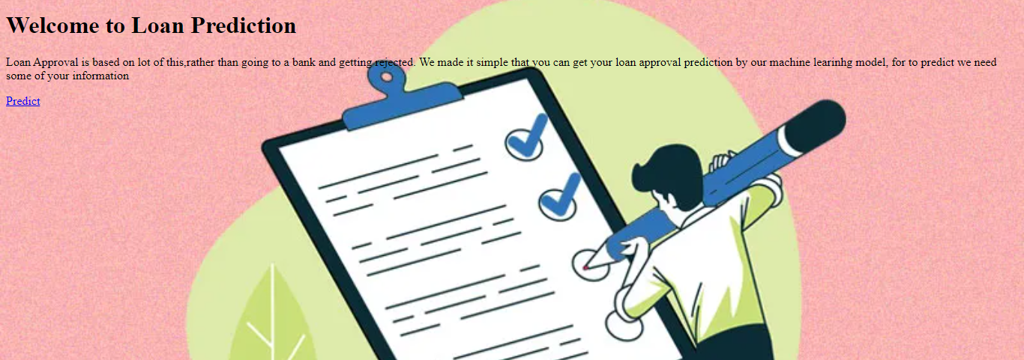
Now when you click on predict button from top right corner you will get redirected to predict.html
Lets look how our predict.html file looks like:
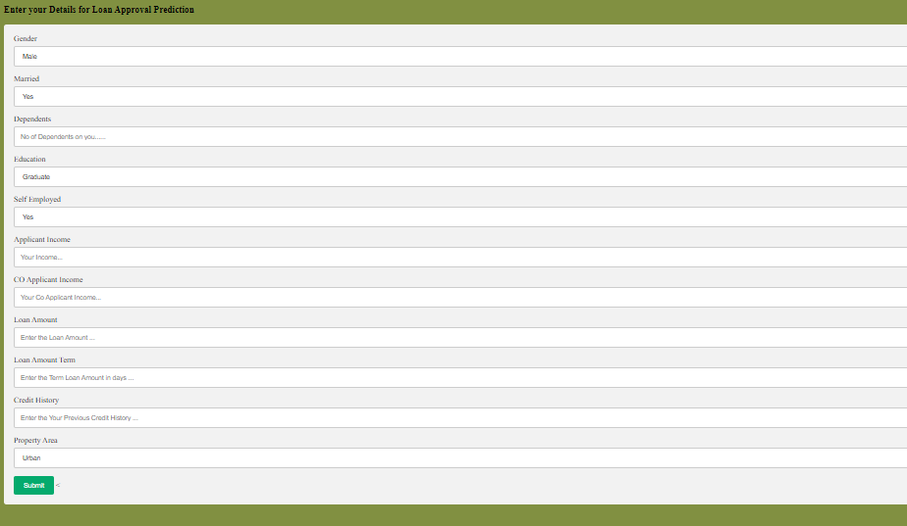
Now when you click on submit button from left bottom corner you will get redirected to submit.html
Lets look how our submit.html file looks like:
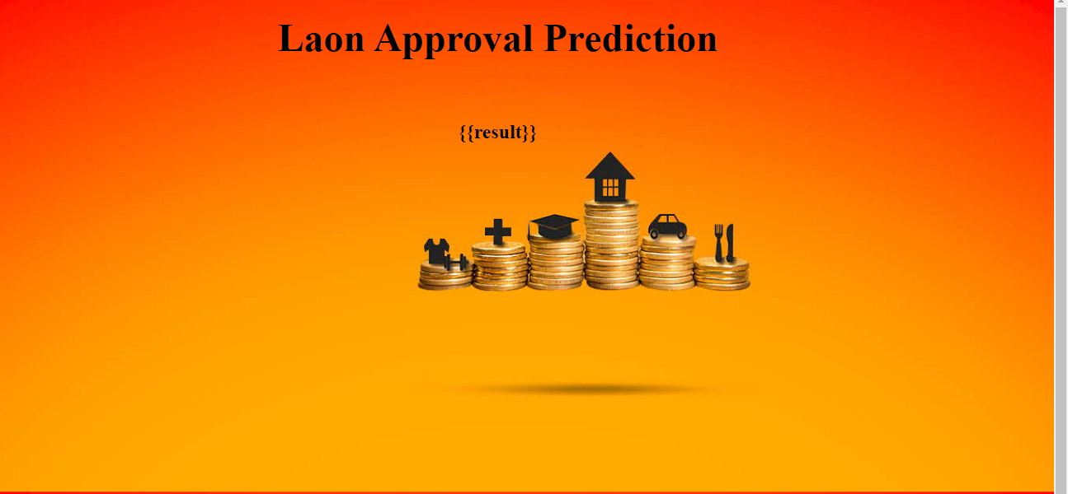
Activity 2: Build Python code:
Import the libraries
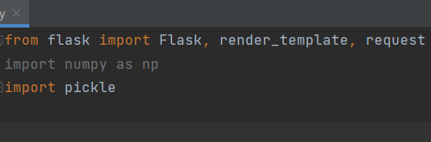
Load the saved model. Importing flask module in the project is mandatory. An object of Flask class is our WSGI application. Flask constructor takes the name of the current module (__name__) as argument.
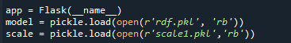
Render HTML page:
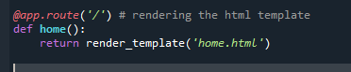
Here we will be using declared constructor to route to the HTML page which we have created earlier.

In the above example, ‘/’ URL is bound with home.html function. Hence, when the home page of the web server is opened in browser, the html page will be rendered. Whenever you enter the values from the html page the values can be retrieved using POST Method.
Retrieves the value from UI:
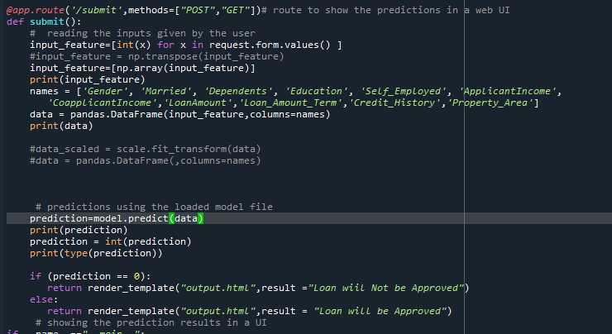

Here we are routing our app to predict() function. This function retrieves all the values from the HTML page using Post request. That is stored in an array. This array is passed to the model.predict() function. This function returns the prediction. And this prediction value will rendered to the text that we have mentioned in the submit.html page earlier.
Main Function:
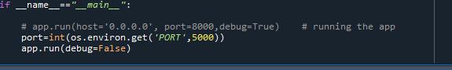
Activity 3: Run the application
- Open anaconda prompt from the start menu
- Navigate to the folder where your python script is.
- Now type “python app.py” command
- Navigate to the localhost where you can view your web page.
- Click on the predict button from top left corner, enter the inputs, click on the submit button, and see the result/prediction on the web.

